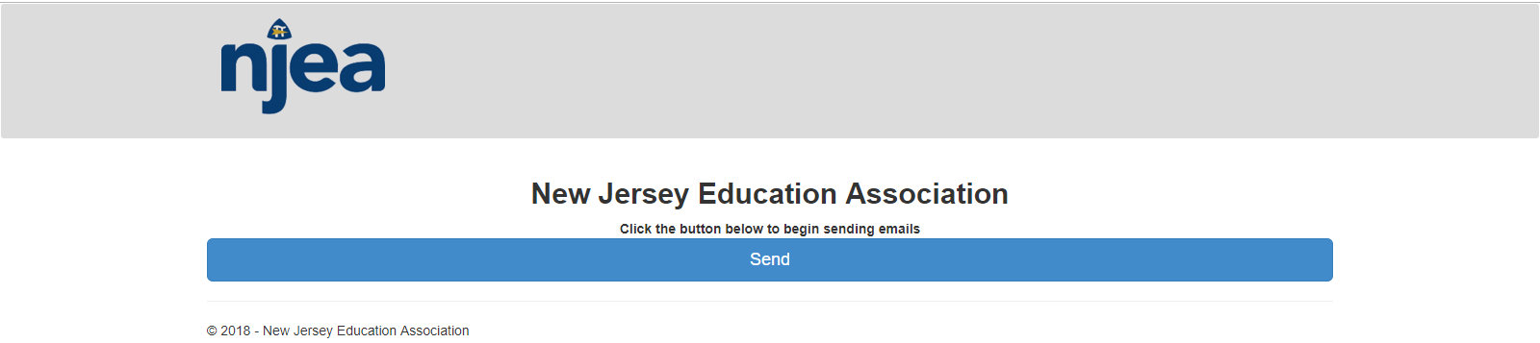

Go to: <http://njeaelections.intelliscaninc-surveys.com/Pages/Nominations/emailblast>

Click the button Send to send the email blast of nominated person in NJEA Report No.2.

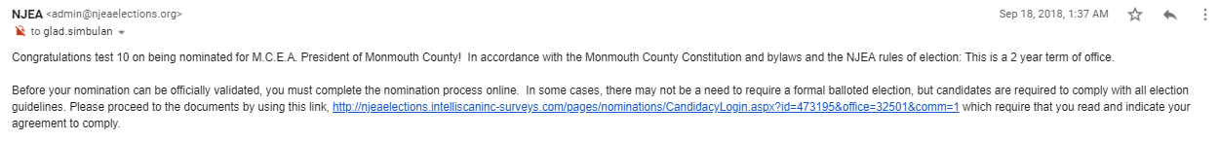

Received email from NJEA for acceptance of nomination.

The highlight link in screenshot that is the form of nomination.